41-47 Wisteria St., Perth Amboy, N.J. (732) 826-4466 Fr. Angelo J. Michaels

St. Demetrios

**Parish Newsletter**

**April 2015**

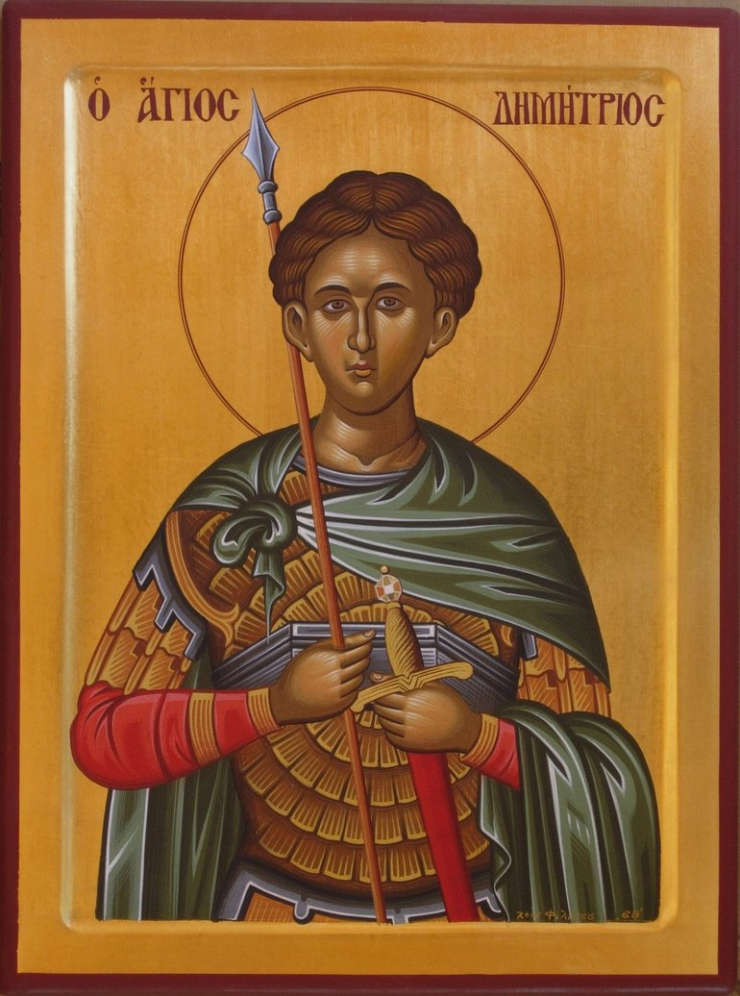



**HOLY WEEK SCHEDULE 2015**

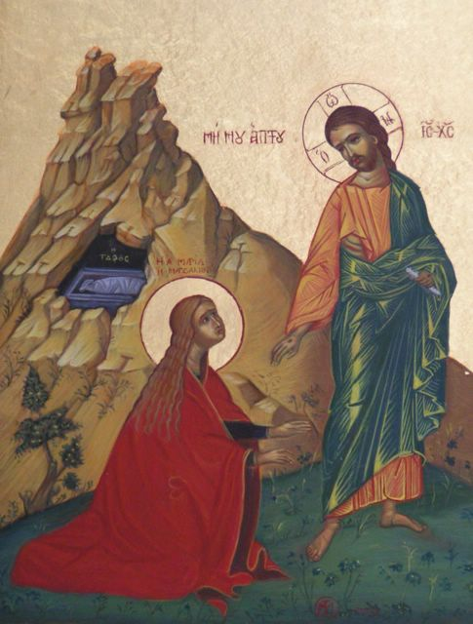

**Jesus Appears to Mary Magdalene**

**JOHN 20:15** Jesus said to her, "Woman, why are you weeping? Whom are you seeking?" Supposing Him to be the gardener, she said to Him, "Sir, if you have carried Him away, tell me where you have laid Him, and I will take Him away." 16Jesus said to her, "Mary!" She turned and said to Him in Hebrew, "Rabboni!" (which means, Teacher).

**Friday April 3**

Pre-Sanctified Liturgy 10 AM

**Saturday April 4**

Saturday of Lazarus Divine Liturgy 10AM

**Sunday April 5**

Palm Sunday Divine Liturgy 10AM

Nymphios 7PM

**Holy Monday April 6**

Nymphios 7PM

**Holy Tuesday April 7**

Nymphios 7PM.

**Holy Wednesday April 8**

Holy Unction 3PM for Children (Eng)

Holy Unction7PM for Adults in (Greek)

**Holy Thursday April 9**

Vesperal Liturgy of St. Basil 6AM Workers Communion 7:30AM-9AM

Passion of Christ 7PM

**Holy Friday April 10**

Royal Hours 9AM

Apokathylosis 3PM

Lamentations 7PM

**Holy Saturday April 11**

Liturgy of St. Basil 8AM

Resurrrection of Christ Div. Lit. 11PM

**Holy Pascha April 12**

Service of Agapi 12PM

Egg hunt for children 1PM

**April 2015 RELIGIOUS CALENDAR**

**March 1 Epistle - St. Paul's Letter to the**

**Hebrews 11:24-26, 32-40**

**Ἑβραίους 11:24-26,32-40**

**Gospel - John 1:43-51**

**Ἰωάννην 1.44-52**

**March 8 Epistle - St. Paul's Letter to the**

**Hebrews 1:10-14; 2:1-3**

**Ἑβραίους 1:10-14; 2:1-3**

**Gospel - Mark 2:1-12**

**Μᾶρκον 2.1-12**

**March 15 Epistle -St. Paul's Letter to the**

**Hebrews 4:14-16; 5:1-6**

**Ἑβραίους 4:14-16; 5:1-6**

**Gospel -Mark 8:34-38; 9:1**

**Μᾶρκον 8.34-38, 9.1**

**March 22 Epistle - St. Paul's Letter to the**

**Hebrews 6:13-20**

**Ἑβραίους 6:13-20**

**Gospel - Mark 9:17-31**

**Μᾶρκον 9.17-31**

**March 29 Epistle - St. Paul's Letter to**

**the Hebrews 9:11-14**

**Ἑβραίους 9:11-14**

**Gospel - Mark 10:32-45**

**Μᾶρκον 10.32-45**

[www.stdemetriosperthamboy.org](http://www.stdemetriosperthamboy.org)



Annual PALM SUNDAY LUNCHEON SUNDAY APRIL 5TH RESERVATIONS PG 6

JOIN US AS ONE FAMILY

**SERVICES (unless otherwise stated)**

Sunday Orthros 9:00 A.M.

Divine Liturgy 10:00 A.M.

**ANNOUNCEMENT FOR SACRAMENTS**

No Baptisms will be scheduled during any of the Great Feast Days of the Lord.

Dearly Beloved,  
  
The Holy and Great resurrection of Christ confronts us once again with the mystery of life over death.  
  
CHRIST IS RISEN. HE IS TRULY RISEN  
CHRIST IS RISEN, AND LIFE REIGNS  
CHRIST IS RISEN, AND NOT ONE DEAD REMAINS IN THE GRAVE!  
  
The resurrection of Christ and the faith in the resurrection make the whole difference for the fulfilled and wholesome human person, as it distinguishes itself from the fallen human nature, where there is no meaning to life, no faith, and no hope. For us, dearly beloved, the fulfillment is of "human -person" Life, not for death, which is the absence of life. Therefore as much as we continue to derive our life from the source of life, and depend on it, we continue to receive from God the gift of life that conquers and overcomes death.  
  
Christ, beloved, descended in Hades, and with the same life-giving hand with which he created the world, he smashed the bars of hell and death. He gave eternal salvation and freedom from death to all who from ages slept there. Christ suffered death in his humanity, changed the fate of the entire human race, allowing it to achieve its final destination, abundant life in God. This triumph of life over death is the object of celebration on this bright day of Holy Pascha.  
  
Christ died and rose from the dead on behalf of all of us. He died and rose so that our life which death and corruption of death cannot overcome, may become the inheritance of every human person.  
  
Are we as Orthodox Christians going to keep this event a secret, hidden from the human race? Are we going to continue letting ourselves and others die without giving ourselves and them a chance to know that our choice is the risen Lord? The alteration to death is eternal life of incorruptibility.  
  
Let us face the challenge that the risen Lord, the Lord and Savior Jesus offers us this Pascha. The challenge is not to allow Christ's death to have happened in vain for us, our church and for the world, let us not allow the victory over death by death of the deathless to be forgotten. CHRIST IS RISEN, make it known to all those who have the right to life, our choice to opt for this abundant life which gushes forth from the tomb of the Chief  and Source  of life, THE RESURRECTED CHRIST.  
  
Let us face the challenge that the risen Lord, the Lord and Savior Jesus offers us this Pascha.  
  
May the risen Lord and all the grace of his gifts be renewed in our hearts this Easter and bright week abide with all of us always.

CHRIST IS RISEN!!  
With deep paternal love in the risen Lord!!

Father Angelo J. Micheals Protopresbyter

**Message from Father Angelo**

Η ανακοίνωση του Πρωτοπρεσβυτέρου

Αγαπητοί ενορίτες,

Η Αγία και Μεγάλη ανάσταση του Χριστού μας φέρνει αντιμέτωπους για άλλη μια φορά με το μυστήριο της ζωής επί του θανάτου.  
  
Χριστός Ανέστη! Αληθώς ανέστη!  
  
Η ανάσταση του Χριστού και η πίστη στην ανάσταση Του κάνει ένας άνθρωπος να είναι υγιεινός, όπως διακρίνεται από την πεσμένη ανθρώπινη φύση, όπου δεν υπάρχει νόημα στη ζωή, χωρίς πίστη και χωρίς καμιά ελπίδα. Για μας, αγαπητοί μου, η εκπλήρωση πρόκειται για την ανθρώπινη ζωή, όχι για το θάνατο, που είναι η απουσία της ζωής. Ως εκ τούτου, όσο συνεχίζουμε να αντλήσουμε την ζωή μας από την πηγή της ζωής, και εξαρτώνται από αυτήν την πηγή, συνεχίζουμε να λαμβάνουμε από τον Θεό το δώρο της ζωής που ξεπερνά τον θάνατο.  
  
Ο Χριστός, αγαπημένη μου, κατέβηκε στον Άδη, και με το χέρι Του, το οποίο δημιούργησε τον κόσμο, έσπασε τα κάγκελα της κόλασης και του θανάτου. Έδωσε την αιώνια σωτηρία και την ελευθερία από το θάνατο σε όλους. Χριστός υπέστη το θάνατο στην ανθρώπινη ζωή Του να αλλάξει τη μοίρα της ολόκληρης ανθρώπινης φυλής. Αυτό το θρίαμβο της ζωής επί του θανάτου είναι το λόγο γιορτής σε αυτήν την φωτεινή ημέρα του Αγίου Πάσχα.  
  
Ο Χριστός πέθανε και αναστήθηκε για όλους μας. Πέθανε και αναστήθηκε, έτσι ώστε η ζωή μας, η οποία δεν μπορεί να ξεπεράσει το θάνατο, μπορεί να γίνει η κληρονομιά του κάθε ανθρώπου.  
  
Πρέπει, ως Ορθόδοξοι Χριστιανοί, να κρατήσουμε αυτό το συμβάν ένα μυστικό από την ανθρώπινη φυλή; Θα συνεχίσουμε να αφήνουμε τους άλλους να πεθάνουν χωρίς να τους δίνουμε την ευκαιρία να γνωρίζουν ότι η επιλογή μας είναι η ανάσταση;   
  
Ας αντιμετωπίσουμε την πρόκληση που μας προσφέρει ο Κύριος και Σωτήρας Ιησούς αυτό το Πάσχα. Η πρόκληση είναι να μην επιτρέψουμε να έχει συμβεί το θάνατο του Χριστού μάταια. ΧΡΙΣΤΟΣ ΑΝΕΣΤΗ, να πούμε σε όλους ότι έχουμε τη ευκαιρία να επιλέξουμε την αιώνια ζωή.

Είθε ο Κύριος και όλη η χάρη των δώρων Του να ανανεωθούν στις καρδιές μας αυτό το Πάσχα και αυτήν την φωτεινή εβδομάδα συμμορφώνονται με όλους μας για πάντα. ΧΡΙΣΤΟΣ ΑΝΕΣΤΗ!!  
  
Ας αντιμετωπίσουμε την πρόκληση που μας προσφέρει ο Κύριος και Σωτήρας Ιησούς αυτό το Πάσχα.

ΧΡΙΣΤΟΣ ΑΝΕΣΤΗ!!

Πάτερ Άγγελος Μιχαλιός

Πρωτοπρεσβύτερος

Parish Council

Marina Corodemus – President

George Petrakakis – Vice President

Dino Kusulas - Treasurer

Helen Horan – Secretary

Steve Corodemus

Elizabeth DaCunha

Kateina Ganiaris

Nick Giannakopoulos

Spero Kalambakis

Afroula Kanelidis

Michael Koudis

Maria Mantoudakis

Irene Pakis

Mark Rasimowicz

Alex Vosinas

**G.O.Y.A. President**

Marie Kahlil

**G.O.Y.A. Advisors**

Stacey Vosinas

**P.T.O. President**

Liz DaCunha

**Greek School Teacher**

Theodora Lykouras

**Greek School President**

Jennifer Simatos

**Sunday School Superintendent**

Barbara Dulin

**Choir Director**

Irene Pakis

**Chantor**

Stavros Tsapatsaris

**Deadline for submissions for the May 2015 Bulletin is**

**April 10, 2015.**

Support the monthly newsletter. Submit your photo-ready business card today. For more details about ad rates please contact d.kusulas@optonline.net.

**NEWSLETTER EDITORIAL BOARD**

Fr. Angelo J. Michaels

Marina Corodemus

Dino Kusulas

Mary Lou Rivera

Sylvia Kress - Director of Advertising

**PRESIDENT’S MESSAGE APRIL 2015**

PRESIDENT’S MESSAGE:

**COME RECEIVE THE LIGHT- COME RECEIVE THE LIGHT John 1:1-17**

**On the eve of Pascha, at Midnight when the priest takes light from the vigil light and gives it to the faithful singing “Come ye and receive light from the unwaning life, and glorify Christ, who arose from the dead," at that moment our church, our faith and our soul should explode with the light of the resurrection. Will you be there?**

Starting with the Saturday of Lazarus and through the Pascha Sunday of AGAPE services, we journey with our Lord through the Passion of His suffering, His humiliation, His Torture, His Betrayal, His Death and then His Resurrection. Will you walk the walk with Jesus this year? Or will you just talk the talk about being a Christian?

This Passion Week, I invite you to walk with our Lord not just for Pascha, but every day and evening of Holy Week. The Light of Resurrection, or the lack of it, is not just symbolic during this week. For example, Holy Monday; we begin with the Hymn of the Bridegroom, "Behold the Bridegroom comes in the midst of the night...beware, therefore, O my soul, lest thou be borne down in sleep...and lest thou be shut out from the Kingdom...", The darkness of Holy Thursday and Friday. It is not until that midnight service that we see and feel the light of Christ’s warmth. Trampling down death.

Come receive the light within YOUR church, with your family and YOUR friends. In the last several months monumental changes have taken place in St. Demetrios which slowly but steadily is finding a new, vibrant, and loving atmosphere for all to share. We have the most energetic and unified Board of Trustees in the last 25 years. We have new ideas, plans, programs and prayerfulness that have brought our community together. But all of this fails unless we recognize the importance of this HOLY WEEK observance. For indeed this is the essence of our spirituality and existence.

So this month come to church and will all of us RECEIVE THE LIGHT.

**MARINA CORODEMUS, PRESIDENT**

**St. Demetrios Board of Trustees.**

**St. Demetrios Philoptochos of Three Hierarchs Chapter 1032**



Let us scatter our love selflessly to all, without regard to the way they act towards us. When the grace of God enters us, we will not be concerned about whether they love us or not or whether they speak to us politely or not. We will feel the need to love all people. It’s egotism on our part to wish for others to speak to us politely. If they don’t, we shouldn’t be upset. Let them speak to us as they wish. We needn’t become beggars for love. Our aim should be to love them and pray for them with all our soul. Then we will become aware that all people love us without our seeking it and without our begging for their love. They will love us freely and sincerely from the depths of their heart without our blackmailing them. When we love without seeking to be loved, people will gather around us like bees. This is true for everyone.

—Elder Porphyrios,

Dear Philoptochos Members – Our membership drive for 2015 as well as the fundraiser for St. Nicholas Shrine are underway. Please support our efforts and attend the meetings and/or events.

**April 3** - Making of the Palm Crosses (9:30 a.m.)

* 25th Annual Concert – “The Spirit of Lent” held at Holy Trinity

**April 5** - Lenten fellowship luncheon and bake sale (Palm Sunday – A portion of the proceeds will benefit the St. Nicholas Shrine)

**April 6-11** - Holy Week (Thursday Eggs & Flowers preparation)

**April 12** - EASTER

**May 10** - Mother’s Day (Mother of the Year)

**May 11** - Clergy Laity

**May 16** - SAVE THE DATE! Ladies Luncheon - Everybody is invited. Catch up with friends and make new ones. Details will follow.

**May 25** - Election for new Philoptochos Board 2015-2017

Kali Anastasi!

Stella Wacker

President of Philoptochos Society

of St. Demetrios

**Stewardship Q&A**

***Why do we pledge?*** This church belongs to each of us. We pledge to fund the daily operations and to ensure that the church and its resources are here for us and for others now and in the future.

***What is the money used for?*** Pledge and other revenue sources (rental, investment, fundraising, donations) support our worship and personnel, priest, cantor, custodian, secretary, janitor, our religious education program, programs for members and friends, community outreach, support of the Metropolis and Archdiocese.

***Is pledging a requirement of membership?*** We ask that those who benefit from the church and participate in activities will share in its financial upkeep. Some members are able to pledge more, others less, but we can all share in supporting our church.

***Should everyone pledge the same amount?*** We place a high value on diversity in our congregation—diverse views, backgrounds, and experiences. Included in this diversity is a diversity of economic circumstances. All of us support our church at individual financial levels.

***How much should I pledge?***  Plan to contribute whatever you feel you can. God’s house is open to all there is no cover charge for admission.

***What about the money I put in the collection plate?*** Some people use the Sunday offering to make their pledge payments. As long as the offering can be associated with you, e.g. your personal check, whatever you put in the offering will be counted toward your pledge or now you can also do so on line. www.stdemetrios perthamboy.org

***What if my financial circumstances change during the year, if I lose my job or have a financial emergency?***  Lives are not static. Contact the Parish President Marina Corodemus or Stewardship Chairperson Maria Mantoudakis, if you need to adjust your pledge.

***But I am active in Philoptochos/GOYA/ PTO/ Sunday School isn’t that enough?*** Is it enough to belong only to the parts and not the whole? Each of these organizations is important and vital and a plus for the community, but each is only a part of the entire church community.

**Why give to this church, because I don’t like:** *The Parish Council, the choir, the priest, the Sunday School?* What we do with what we have directs our heart. Giving to God reminds us that He has given us everything we have, and can be counted on to meet every need we will ever have. And The Church is His plan, through Jesus, to reconcile the world to himself. To bring healing through relationships, to support one another and encourage one another. So we give, to advance the gospel through His ministry.

**GIVE TO THE HOUSE OF God and not AGAINST one person, place or thing.**

**The SErvices of Holy Week**

The services of Holy Week transform us into eyewitnesses and direct participants in the awesome events of the Passion and Resurrection of Jesus Christ. In readings taken from both Old and New Testaments, in hymns, processions, and liturgical commemoration, we see the fulfillment of the Messianic prophecies, and the mighty acts by which God Himself, in the person of Jesus Christ, grants us forgiveness for our sins, and rescues us from the pain of eternal death.

**PALM SUNDAY EVENING**

This evening’s service calls to mind the beginning of Jesus’ suffering. The Gospel describes the plotting of the priests and elders to trap Jesus into convicting Himself as a religious heretic. Through parables, Jesus tells us of His coming betrayal, trial, conviction and execution by crucifixion. The hymns of this service commemorate two things: The first, the prophetic figure of Joseph, who, while virtuous, nonetheless suffered unjustly at the hands of his brothers before being greatly rewarded; and the second, the parable of the fig tree, which in failing to bear fruit, became a symbol of fallen creation, and of our own lives, in which we also have failed to bear spiritual fruit. Scripture readings for this service are taken from: Matthew 21:18-43.

**HOLY MONDAY EVENING**

This evening’s theme is the need for watchfulness and preparation, lest we be called unprepared before the awesome judgement seat of Christ to render an account of ourselves. The gospel reading contrasts the efforts of the Pharisees to trick and discredit Jesus with the forceful resistance which Christ mounts against their evil. The hymns remind us of the parable of the Ten Virgins, in which the faithful Christian is exhorted to vigilance. Scripture readings for this service are taken from: Matthew 22:15-46; 23:1-39

**HOLY TUESDAY EVENING**

The need for true repentance is the concern of Tuesday evening’s service. This transformation from the life of sin to a life of faith and obedience is exemplified for us in the person of the sinful woman who received the gift of forgiveness when she anointed Jesus with myrrh and washed His feet. The highlight of this service is the hymn written in honor of this woman by St. Kassiani. The Gospel meditation foretells of the coming suffering of Christ and recalls His inner struggles and agony. Scripture readings for this service are taken from: John 12:17-50.

**HOLY WEDNESDAY AFTERNOON/EVENING**

The primary theme of Holy Wednesday is our human need for the healing and forgiveness that comes into our lives when we establish a relationship with God through Jesus Christ. We are reminded that the way to this relationship is to be found, above all else, through the life of prayer. In the Sacrament of Holy Unction, the faithful are anointed and thus, healed both physically and spiritually. They are also reconciled to God and one another so that they might receive the gift of the Holy Eucharist instituted by Christ at the Last Supper. Scripture readings for this service are taken from: Epistle readings: James 5:10-16, Romans 15:1-7, I Corinthians 12:27-31-13:1-8, II Corinthians 1:8-11. Galatians 5:22-6:2, I Thessalonians 5:14-23. Gospel readings: Luke 10:25-37, Luke 19:1-10, Matthew 10:1 & 10:5-8, Matthew 8:14-23, Matthew 25:1-13, Matthew 15:21-28, and Matthew 9:9-13.

**THE PRAYER OF ANOINTING**

O Holy Father, Physician of souls and bodies, Who didst send Thine only-begotten Son, our Lord Jesus Christ, to heal every infirmity and deliver from death: Heal Thou, also, Thy servants from the ills of the body and soul which do hinder them, and quicken them, by the Grace of Thy Christ; through the prayers of our most Holy Lady, the Birth-Giver of God and Ever Virgin Mary; through the intercession of the honorable bodiless Powers of Heaven; through the power of the Precious and Life-Giving Cross; through the protection of the honorable, glorious, Prophet and Forerunner John the Baptist; of the holy, glorious and righteous Martyrs; of our righteous and Godbearing Fathers; of the holy and healing unmercenaries Cosmas and Damian, Cyrus and John, Thaleleus and Tryfon, Panteleimon and Hermolaus, Samson and Diomidis, Mokius and Aniketos; of the holy and righteous ancestors of God, Joachim and Anna; and of all the Saints. For Thou art the Fountain of healing, O God, our God, and unto Thee do we ascribe glory, to the Father, and to the Son, and to the Holy Spirit, now and ever, and to the ages of ages. Amen

**HOLY THURSDAY MORNING**

“On the night when He was betrayed, or rather when He gave Himself up for the life of the world, He took bread in His holy, pure, and blameless hands, gave thanks, blessed, sanctified, broke, and gave it to His holy disciples and apostles saying...” — Taken from the Divine Liturgy of Saint John Chrysostom On Holy Thursday morning, we ascend Mt. Zion with Christ and the Twelve, and enter into the upper room. Once there, we witness the awesome moment when, at the Last Supper, Christ abolishes the ritual practice of the Old Covenant and establishes the ritual of the New Covenant, prophesied by Jeremiah, through the Sacrament of Holy Communion. The faithful receive Holy Communion at that Holiest of Liturgies. Scripture readings for this service are taken from: Matthew 26:2-20, John 13:3-17, Matthew 26:21-39, Luke 22:43-45, and Matthew 26:40-27:2.

**HOLY THURSDAY EVENING**

In this service, we commemorate the undeserved suffering of Jesus Christ, endured for our sake, so that we might be reconciled anew to God our Father. The Gospel readings witness for us the betrayal and arrest of Jesus, his trial and conviction, and finally his torture, crucifixion and death at the hands of a sinful humanity. This evening’s service also includes the procession representing Christ carrying His own cross along the Via Dolorosa, and ends when we see before us the King of Glory crucified. Scripture readings for this service are taken from:

**1.** John 13:31-18:1 **2.** John 18:1-29 **3.** Matthew 26:57-75 **4.** John 18:28-19:16 **5.** Matthew 27:3-32* **6.** Mark 15:16-32 **7.** Matthew 27:33-54 **8.** 23:32-49 **9.** John 19:25-37 **10.** Mark 15:43-47 **11.** John 19:38-42 **12.** Matthew 27:62-66.

After the reading of the fifth Gospel comes the procession with the Crucifix around the church, while the priest chants the Fifteenth Antiphon:

“Today is hung upon the Tree, He Who did hang the land in the midst of the waters. A Crown of thorns crowns Him Who is King of Angels. He is wrapped about with the purple of mockery Who wrapped the Heavens with clouds. He received buffetings Who freed Adam in Jordan. He was transfixed with nails Who is the Bridegroom of the Church. He was pierced with a spear Who is the Son of the Virgin. We worship Thy Passion, O Christ. Show also unto us thy glorious Resurrection.”

**HOLY FRIDAY AFTERNOON**

In this service, we are once again reverent witnesses to the undeserved suffering of Christ, to his terrible passion and death. What is remembered in a special way through liturgical commemoration and procession, is the faithfulness and love of Joseph of Arimathea who tenderly removed Christ’s body from the cross, wrapped it in clean linen, and carried it to his own unused tomb for burial. Scripture readings for this service are taken from: I Corinthians 1:18- 2:2, Matthew 27:1-38, Luke 23:39-43, Matthew 27:39-54, John 19:31-37, and Matthew 27:55-61.

**ORTHODOX CELEBRATION OF GREAT AND HOLY FRIDAY**

As the priest proclaims the Gospel, “And Joseph took the body, and wrapped it in a clean linen shroud, and laid it in his own new tomb...” he removes the Body of Christ from the Cross, wraps it in a new white cloth and takes it to the altar. The priest then chants the hymn: “When Joseph of Arimathea took You, the Life of all, now dead, down from the Cross, he buried You in fine linen, after anointing You with myrrh. He yearned with desire, humbly contained by awe, rejoicing, he cried out to You: Glory to Your condescension, O merciful God!”. The priest then carries the Epitaphios, the cloth on which the Body of Christ is painted or embroidered, around the church before placing it inside the Sepulcher, a carved bier which symbolizes the Tomb of Christ.

**HOLY FRIDAY EVENING**

On Holy Friday evening, the theme is Christ’s descent into Hades during which the Gospel of repentance and reconciliation with God is shared with those who died before Christ’s saving dispensation in the flesh. The service begins with lamentations sung as we stand before the tomb of Christ commemorating His unjust punishment and the shedding of His innocent blood. But the service ends on a note of joy and hope, with the reading of the Prophet Ezekiel in which he describes his vision of our resurrection yet to come; in the midst of despair, we are told there is hope, for not even death can separate us from the unfailing love and power of God. Death is about to be conquered and faithfulness rewarded. Scripture readings for this service are taken from: Ezekiel 37:1-14, I Corinthians 5:6-8, Galatians 3:13-14, Matthew 27:62-66.

**HOLY SATURDAY MORNING**

On Holy Saturday morning we celebrate the theme of faithfulness receiving its reward. The crucifixion is over, Christ is buried, the twelve apostles and other disciples are scattered and defeated. And yet, three myrrh-bearing women come in faithfulness to perform the last act of love—to anoint Jesus according to the Jewish burial custom. Their unwavering devotion is rewarded—they are the first to share in Christ’s triumph over evil and death. They are the first witnesses to the Resurrection. This joy is commemorated through the scattering of bay leaves and rose petals by the priest. Scripture readings for this service are taken from: Romans 6:3-11 and Matthew 28:1-20.

**HOLY SATURDAY EVENING/ EASTER SUNDAY MORNING**

The lamentations of the previous night are repeated and the church is plunged into darkness to symbolize the despair and defeat experienced before the dawn of Christ’s victory over the Enemy of our salvation. Precisely at midnight, a single light emerges from the altar representing the victory of Christ over death, the defeat of the Prince of Darkness by Jesus, the Light of the World. As the light is passed from person to person, it pushes back the darkness of the church and defeats it completely. The Resurrection is proclaimed in song and triumphant procession, and after the Liturgy, its light is carried into our homes so that they too might be filled with its light and warmth and triumph. Scripture readings for this service are taken from: Mark 16:1-8

Christ’s Resurrection and victory is affirmed in this morning’s theme. The Gospel is read in several languages to illustrate the universality of the Good News of the Resurrection and its proclamation to the very ends of the earth. Love, forgiveness, reconciliation, triumph and joy—these are the gifts which we receive because Christ lived and died and triumphed for our sake. Scripture readings for this service are taken from: John 20:19-25.





**In Memoriam**

This April 10th marks 13 years since the falling asleep in the Lord of our beloved Husband, Father and Papou, John Ahladianakis.

December 3, 1943 – April 10, 2002.

May his memory be eternal.

Argiro, Nikos, Gary, John and Matthew Ahladianakis

Starting **HOLY WEEK** our church will begin using **BEES WAX CANDLES** made by the **Sisters of Agia Skepi**.

These candles are environmentally more friendly, produce less soot and the money goes to help support the monastery

So please give generously when you buy your next candle.

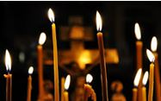

**HELP US BUILD AN UP-TO-DATE PARISHIONER MAILING LIST AND DATABASE**

**PLEASE COMPLETE THE BELOW FORM AND SUBMIT IT TO THE CHURCH OFFICE**

**AN UPDATED PARISHIONER DATABASE WILL GO A LONG WAY TO HELPING THE PARISH COUNCIL BETTER SERVE EVERYONE IN THE COMMUNITY**

**Parishioner Information Form**

**First Name Last Name**

**Address**

Street Address________________________ City ________________State______Zip Code______

Alternate Street Address­­­________________ City________________State______Zip Code______

**Contact Information**

Home Phone________________Mobile______________Email______________________________

**Personal Information**

Gender_______ Marital Status_______________ Date of Birth__________

Membership Date____________Anniversary Date__________School Year / Grade____________

**Care Information**

Allergies and Special Instructions

Emergency Contact / Relationship

**GUS KRARAS**

**26 E. Lancaster Ave.**

**Reading, PA 19607**

**(800) 437-2323**

**(610) 775-5000**

**FAX (610) 775-7155**

**4 OF ST. DEMETRIOS’ OWN TO PERFORM WITH NJ DISTRICT CHOIR**

Anna Kyriakatos, Zeffie Tzitzis, Argyro Ahladianakis and Irene Pakis will be representing St. Demetrios Perth Amboy as part of this year’s Lenten Choir. The choir’s upcoming event is being billed as “The Spirit of Lent – 25th Anniversary Concert – Ancient and Modern Choral Works”.

This year’s choir is composed of 60 men and women from parishes throughout New Jersey and Staten Island.

The Concert will take place Friday April 3rd 8pm at Westfield’s Holy Trinity Greek Orthodox Church, 250 Gallows Hill Road. Admission is $10 and children under 12 are admitted free.

**SPONSORSHIP**

**OPPORTUNITIES**

**AVAILBLE**

**Many thanks to Sylvia Kress for her hard work coordinating sponsorship for this newsletter**

**Support Our Community**

**&**

**Support Our Sponsors**

**Many thanks to our sponsors, our patrons, for their support of this newsletter**

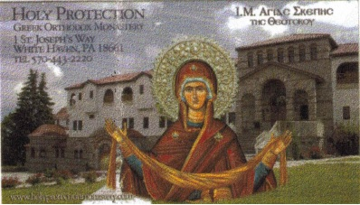





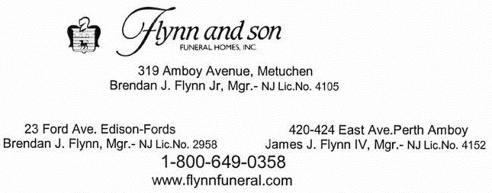

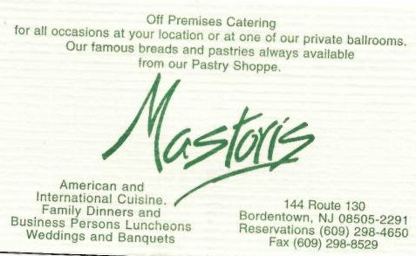



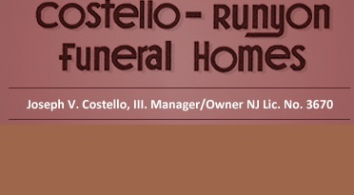

**WWW.COSTELLO-RUNYON.COM**

**568 Middlesex Avenue**

**Metuchen, NJ 08840**

**(732) 548-0149**

**1225 Green Street**

**PO Box 24**

**Iselin, NJ 08830**

**(732) 283-0075**

|  | **~ Απρίλιος 2015 ~** | | | | |  |
| --- | --- | --- | --- | --- | --- | --- |
| **Sun** | **Mon** | **Tue** | **Wed** | **Thu** | **Fri** | **Sat** |
|  |  |  | 1 | 2 | 3  **Προηγιασμένη Θεία Λειτουργία**  **10 π.μ.** | 4  **Ανάσταση του Λαζάρου**  **Θεία Λειτουργία: 10 π.μ.** |
| 5  **Κυριακή των Βαΐων**  **Θεία Λειτουργία: 10 π.μ.**  Πώληση λουλουδιών της Νεολαίας  Πώληση γλυκών της Φιλόπτωχου  Καφέ της Φιλόπτωχου  **7 μ.μ.** | 6  **Η ΜΕΓΑΛΗ ΔΕΥΤΕΡΑ**  **7 μ.μ.** | 7  **Η ΜΕΓΑΛΗ ΤΡΙΤΗ**  **7 μ.μ.** | 8  **Η ΜΕΓΑΛΗ ΤΕΤΑΡΤΗ**  Το Μέγα Ευχέλαιο των παιδιών **3 μ.μ.**  Το Μέγα Ευχέλαιο των ενηλίκων **7 μ.μ.** | 9  **Η ΜΕΓΑΛΗ ΠΕΜΠΤΗ**  **Θεία Λειτουργία του Αγίου Βασιλείου**.  **6 π.μ.**  Θεία Κοινωνία των εργατών  730 π.μ. - 9π.μ.  Tα Πάθη του Ιησού  **7 μ.μ.** | 10  **Η ΜΕΓΑΛΗ ΠΑΡΑΣΚΕΥΗ**  Βασιλικές ώρες  **9 π.μ.**  Αποκαθήλωση **3 μ.μ.** & Τα εγκώμια **7 μ.μ.** | 11  **ΤΟ ΜΕΓΑΛΟ ΣΑΒΒΑΤΟ**  **Λειτουργία: 8 π.μ.**  **Ανάσταση**  **10 μ.μ** |
| 12  **Άγιο Πάσχα**  Εσπερινός της Αγάπης **10 μ.μ.**  Ψάξιμο των πασχαλινών αυγών  **1 μ.μ.**  Καφέ του PTO | 13 | 14 | 15 | 16 | 17 | 18 |
| 19  Καφέ της Νεολαίας | 20 | 21 | 22 | 23 | 24 | 25 |
| 26  Καφέ του Συμβουλίου | 27 | 28 | 29 | 30 |  |  |

|  | **~ April 2015 ~** | | | | |  |
| --- | --- | --- | --- | --- | --- | --- |
| **Sun** | **Mon** | **Tue** | **Wed** | **Thu** | **Fri** | **Sat** |
|  |  |  | 1 | 2 | 3  **Presanctified Liturgy** 10am  6th Friday of Lent | 4  **Saturday of Lazarus**  Divine Liturgy 10am |
| 5  **Palm Sunday**  Palm Sunday Bake Sale- Philoptochos  Plant Sale- Goya  Philoptochos- Coffee Hour  Nymphios 7pm | 6  **Holy Monday**  Nymphios 7pm | 7  **Holy Tuesday**  Nymphios 7pm | 8  **Holy Wednesday**  Holy Unction  7pm | 9  **Holy Thursday**  Vesperal Liturgy 6am  Communion for workers 7309am  Preparing Eggs & Flowers- Philoptochos  ***No Seniors Meeting*** | 10  **Good Friday**  Royal Hours 9am  Apokathylosis 3pm  Lamentations 7pm  Preparing Eggs and Flowers- Philoptochos | 11  **Holy Saturday**  Divine Liturgy 8am  Resurrection of Christ Divine Liturgy 11pm  Making crosses for Palm Sunday- Philoptochos |
| 12  **Pascha**  PTO Coffee Hour | 13 | 14 | 15  **RARITAN AHEPA CHAPTER 288**  **TO HONOR VETERANS**  The local AHEPA chapter, St. Demetrios Chapter 288, plans to honor the military service of our church parishioners this May in tandem with Memorial Day.  If you, or a friend or family member from the St. Demetrios community wish to be recognized for your military service (past or present), please contact either George Petrakakis or email Dino Kusulas at [dkusulas@optonline.net](mailto:dkusulas@optonline.net). | 16 | 17 | 18 |
| 19  Goya Coffee Hour | 20  Goya District Meeting | 21 | 22 | 23 | 24 | 25 |
| 26  Parish Council Coffee Hour | 27 | 28 | 29 | 30  C:\Users\d.kusulas\Dropbox\Newsletter Files\graphics\TNCHRCH33 (1).jpg | **Recent Memorial Services**  **March 1**  40-day memorial Georgia Siggelaki  37-year memorial Theodore Siggelaki  **March 15**  40-day memorial Paul Pappas  10-year Memorial Panagi and Popi Tsilimidos  **March 22**  1-year memorial Kalliope Coutros  **March 29**  40-day memorial James Corodemus  3-month memorial Steve Tzikakos  3-year memorial Evagelia Tzikakos  **MAY THEIR MEMORIES BE ETERNAL!!!** |  |

**VeteranS Commemoration**

This upcoming May, the Saint Demetrios AHEPA Chapter 288 plans to honor all members of the St Demetrios Community, past and present, who have served in the any of the Armed Forces of the United States.

If you or any family member are serving or have served in any capacity (active duty, National Guard or Reserves) please provide George Petrakakis the following:

**Name: ___________________________________________________________**

**Branch: __________________________________________________________**

**Years of Service: ___________________________________________________**

**Rank: ____________________________________________________________**

**Unit: _____________________________________________________________**

**ANYONE WISHING TO ADVERTISE IN THE NEWSLETTER PLEASE CALL ADVERTISING MANAGER SYLVIA KRESS AT**

**732 548 6922**

**NYC Greek Independence Parade**

Anyone interested in chartering a bus to NYC for the Sunday, March 29th Annual Greek Independence Day Parade is asked to contact me as soon as possible.

Thank you!

George N. Petrakakis gpetrakakis@outlook.com 732.522.3797 Mobile





St Demetrios G.O.C.

41-47 Wisteria St

Perth Amboy, N.J. 08861

**Have you visited the St Demetrios Perth Amboy website lately?**

**You can now make donations, and honor your stewardship commitment by making your payments on line at:**

**http://www.stdemetriosperthamboy.org/donations/**

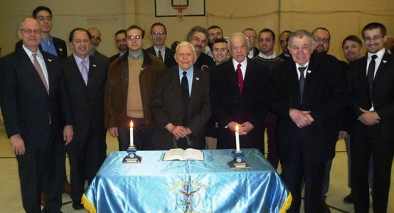

St. Demetrios Greek

Orthodox Church

41-47 Wisteria St.

Perth Amboy, N.J. 08861

Fr. Angelo J. Michaels

Phone: (732) 826-4466

Cell: (908) 612-5108

Fax: (732) 826-4312

E-Mail:

[**frangelom@aol.com**](mailto:frangelom@aol.com)

**ST DEMETRIOS AHEPA REACTIVATED**

**Perth Amboy AHEPA Raritan Chapter #288 was reactivated March 1, 2015 after being dormant for nearly twenty years.**

**The reactivated chapter welcomed the following initiates, reinstatements, and transfers:**

**Fr. Angelo J. Michaels, Atef A. Azous, Christy Corodemus, Steven Corodemus, Spero Coutros, Joseph DaCunha, Bennie DiBlasi, Dimitrios Koudis, Chris N. Kusulas, Dino Kusulas, James A. Lukas, Constantinos Mariolis, George N. Petrakakis, Mark Rasimowicz, Stavros Tsapatsaris, Glenn Viega, Alexandros G. Vosinas, George A. Vosinas, Nikolas P. Vosinas; and posthumously reinstated Eureka #52 Newark, NJ Past President James S. Corodemus.**

We’re on the Web!

Visit us at:

[www.stdemetriosperthamboy.org](http://www.stdemetriosperthamboy.org)

**E-Mail :** **stdgoa@gmail.com**