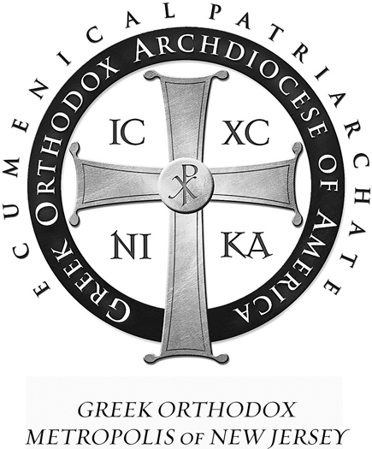 | St Demetrios  Greek Orthodox Church  41-47 Wisteria Street  Perth Amboy, NJ 08861
Rev. Fr. Angelo J. Michaels Tel. (732)826-4466
Protopresbyter Fax (732)826-4312

June 7, 2016

My Dear Brothers and Sisters in Christ,
Glory to God. We have a new priest.

On Sunday, June 19, Pentecost and Father’s Day, Father George Parsenios will celebrate his first Divine Liturgy at St. Demetrios. Father George, recently ordained, first visited our church on March 27, and, again, on Palm Sunday as Deacon George. Now, newly ordained, Father will be joining us with his wife, Presbytera Maureen, and their three children Nicholas, Julia and Konstantinos.

This coming Sunday will be Father Michael’s last Divine Liturgy, so I ask you to please attend to thank and say goodbye to Father and Presbytera. Also, this Sunday will be Greek School Graduation hosted by Kyria Alexandra with our wonderful Greek school children. The Greek school program will be held in church directly after the Divine Liturgy. Please know that our new kitchen is being worked on now, hopefully be completed by June 19th.

So, now let us prepare to meet and greet Father George and His Family on Sunday June 19th, Pentecost and Father’s Day. A light reception will be held by the PTO for the Father of the Year and our new Spiritual Father. All are welcome. Space is limited.

Hope to see you all on both Sunday the 12th and Sunday the 19th. Our church moves forward and more united in the Service of our Lord.

Very Truly Yours,

Judge Marina Corodemus (ret.)
Parish Council President

