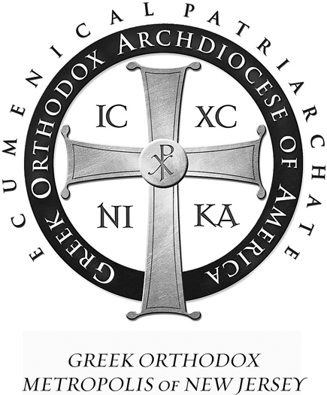 | St Demetrios  Greek Orthodox Church  41-47 Wisteria Street  Perth Amboy, NJ 08861
Rev. Fr. Angelo J. Michaels Tel. (732)826-4466
Protopresbyter Fax (732)826-4312

PRESIDENT’S THANK YOU LETTER

To all those who worked at this year’s St. Demetrios Greek Festival by the Bay 2016,

I can only say THANK YOU from the bottom of my heart for all your hard work. We are a small, but very caring community. When it came time to pitch in for our Church, so many of you worked as hard as I could ever believe people could. Your hours of dedication in the rain, the smoke, heat, and crowds were nothing short of heroic. We do this all not for ourselves, but for our beloved St. Demetrios, to keep its doors open and to remain economically sound.

This year, we took up the challenge of relocating the Festival from the traditional building to an outdoor tent overlooking the Raritan Bay. So many people, Greek and otherwise, commented so positively on our most beautiful view, excellent food and cordial musical atmosphere. This outdoor setting was actually more personal and positive for workers and attendees. Despite two days of rain, we had steady attendance capped off by the record crowd Saturday night. Not only did we set a record for Gyros sold, the Loukoumades line almost rivaled the gyro wait. Each person who worked, whether in pastries and coffee, to the boutique and plants, to finer taverna dining contributed to our most successful raffle trip to Greece and it all paid off.

This year’s expansion into social media of FACEBOOK and our now famous teaser commercial launched our church profile to new horizons. We will certainly capitalize on this new medium. We will be posting pictures of the Festival and winners of our prizes next month.

Finally, to those of you who contributed financially, THANK YOU. Festivals like these also come with large overhead, no matter how hard we try to be conservative. Your checks to help pay our bills equally lent to the profits we earned for our church.

My particular thanks to co-chairs. Spero Kalambakas and Afroula Kanellidis, along with Stan Suravlas, Helen Horan, Maria Mantoudakis, Dennis Krousos, Dino Kusulas, Joanne Kusulas, Nick Giannakopoulos, Irene Pakis, Olga Mamaligas, Froso and Ruben Morales, Helen Catelanos, Mike Koudis and Liz DaCunha. The Parish Council has worked very hard in the last 18 months to spend your donations and earned money wisely all for the Glory of God.

Very Truly Yours,

Judge Marina Corodemus (ret.) Parish Council President

